Children starting school in September 2024

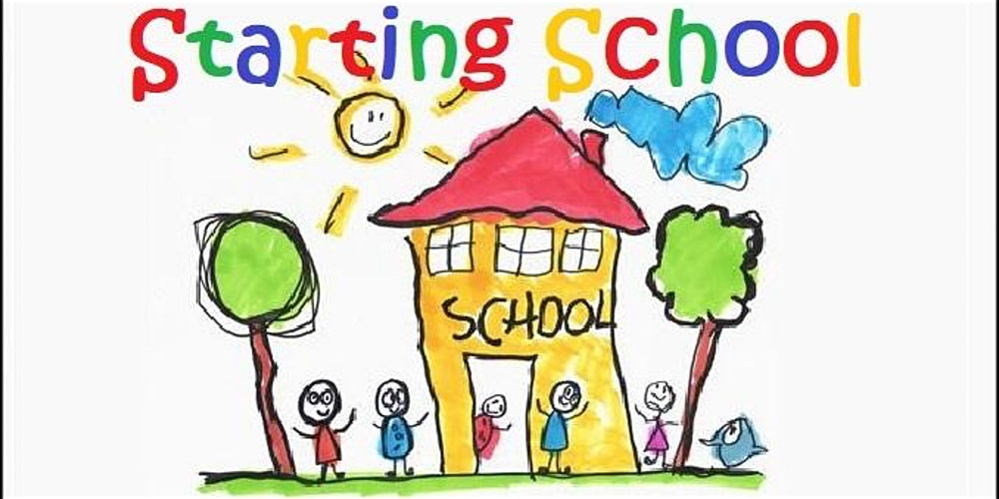

Please let your child’s class teachers know which school your child has been allocated as soon as their school has been confirmed.

FEE INCREASE
We have had a fee structure review, and unfortunately, we will be increasing our fees from 01/04/2024, we have kept this increase to a minimum as we understand that the cost of living is impacting us all right now. Thank you for your understanding. The fees increase is as follows:

Sessions will increase from £8.00 to £8.50 per session
Breakfast club, and lunch clubs will not have a rise, and will remain the same charge.

After school provision

We are going to distribute a questionnaire this term, to gain your interest in an after-school provision during term time, for preschool children, we would not be able to offer this provision to school age children. We would be looking at running until 5.30pm each day and the cost for the extra 2.5 hours would be £12.00. If we receive enough positive feedback then we would look at running these sessions from September, once registered with Ofsted for extra care.

Parking at the rear of preschool

Please DO NOT park in the rear car park, there have been a couple of near misses with children as they walk behind reversing vehicles.
Also if you park on Benyon grove and walk through the cut, please be aware that residents do live there and be respectful to their property.

We do have a large free car park at the front of the building which we would encourage you all to use.

Children receiving Disability Living Allowance
If your child is in receipt of DLA would you please inform the office, preschool may be able to get extra funding to support your child’s learning and interests.
We would just need to photocopy the front award page for evidence.

School Readiness

We are working with the school age children to encourage their school readiness, please work with us by encouraging your child to put on and take off their own coats at the start and end of the day.
Also please ensure children do not bring any toys in from home, as this will help them prepare for primary school.

15 Hours free childcare for 2yr olds

Please remember that if both parents are working, or if a single parent is taking home the equivalent of 16 hours @ minimum wage, you can claim 15 free hours childcare.
Please log onto GOV.UK to make your claim, once you have your 15-hour code, please bring this to the office. The deadline for receiving funding next term is 31/08/2024. If you register after this date, you will not receive 15-hour funding for the September term.

30 free hours childcare

Please remember that if both parents are working, or if a single parent is taking home the equivalent of 16 hours @ minimum wage, you can claim 30 free hours childcare. Please log onto GOV.UK to make your claim, once you have your 30-hour code, please bring this to the office. The deadline for receiving funding next term is 31/08/2024. If you register after this date, you will not receive 30-hour funding for the September term.

Please remember you must resubmit every 3 months for your eligibility to 30 hours and 15 hours free childcare to continue, late submissions will result in fees being charged, these fees will be for the whole term until the next allocation.

Nativity Tickets are now on sale priced at ed l
Xmas Raffle Tickets

