**30 free hours childcare**

Please remember that if both parents are working, or if a single parent is taking home the equivalent of 16 hours @ minimum wage, you can claim 30 free hours childcare. Please log onto GOV.UK to make your claim, once you have your 30-hour code, please bring this to the office. The deadline for receiving funding next term is 31/03/2024. If you register after this date, you will not receive 30-hour funding for the April term.

Please remember you must resubmit every 3 months for your eligibility to 30 hours to continue, late submissions will result in fees being charged, these fees will be for the whole term until the next allocation.

**Free 15 hours for eligible 2yr olds**

**How to claim 15 hours free childcare including where to get your code**

Applications are now open for eligible working parents of 2-year-olds to receive 15 hours free

childcare, starting from April 2024.

You apply online on Gov.uk.

You can only apply for the first phase of the new working parent entitlement if your child is already

2-years-old or will have had their 2nd birthday on or before 31 March 2024.

Children who are born on or after 1 April will become eligible later in the year:

**School Readiness**

We are working with the school age children to encourage their school readiness, please work with us by encouraging your child to put on and take off their own coats at the start and end of the day.

**Parking at the rear of preschool**

Please DO NOT park in the rear car park, last term there were a couple of occasions that were dangerous, and as children arrive and exit through the rear gate, it is not safe for cars to park in this car park. Please use the free large car park at the front of the building and walk around to the rear of the preschool.

Thank you

**50 things to do before you’re 5**

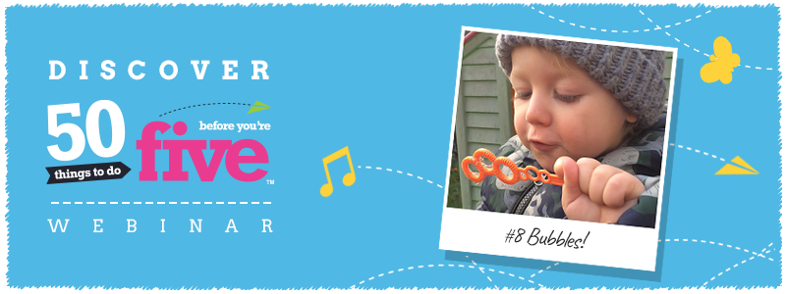

50 things to do before you’re 5 helps children develop the skills, language and resilience needed in school and beyond. This App is available free to download and has some great ideas for you and your children.

**Dates to Remember**  

**Red nose day Friday 15th March 2024**

We will be having dress up for this day £1.00 donation, as well as a cake stall and tombola, children will receive a paper plate to take home for cake donations.

**Easter Bonnet competition** **Thursday 28th March 2024**

We will be holding a competition for decorated bonnets in your child’s class throughout the day, there will be a stall at preschool for you to purchase items from if you wish. You decorate their bonnet at home, then bring it to preschool on Thursday to be judged, we will have a member of the local community judge the bonnets in each room. The winning bonnets will receive a prize. Please join in this fun event.

**Thursday 28th March** Preschool will finish for the half term on this date.

Easter Half Term Tuesday 02rd April – Friday 12th April

We will be running a holiday club during this half term; the cost is £21.50 per day 7.45am – 3.00pm (We will be closed good Friday and Easter Monday)

**Tapestry**  

Please remember to provide the office with your email address, we can then add you on to the electronic learning journal tapestry, where you will be able to see your child’s learning whilst at preschool.

You are also able to share any home events, celebrations and learning through the tapestry link.

**Children receiving Disability Living Allowance**

If your child is in receipt of DLA would you please inform the office, preschool may be able to get extra funding to support your child’s learning and interests.

We would just need to photocopy the front award page for evidence.

Nativity Tickets are now on **sale** priced at ed l

**Xmas Raffle Tickets**