Herlington Pre-school
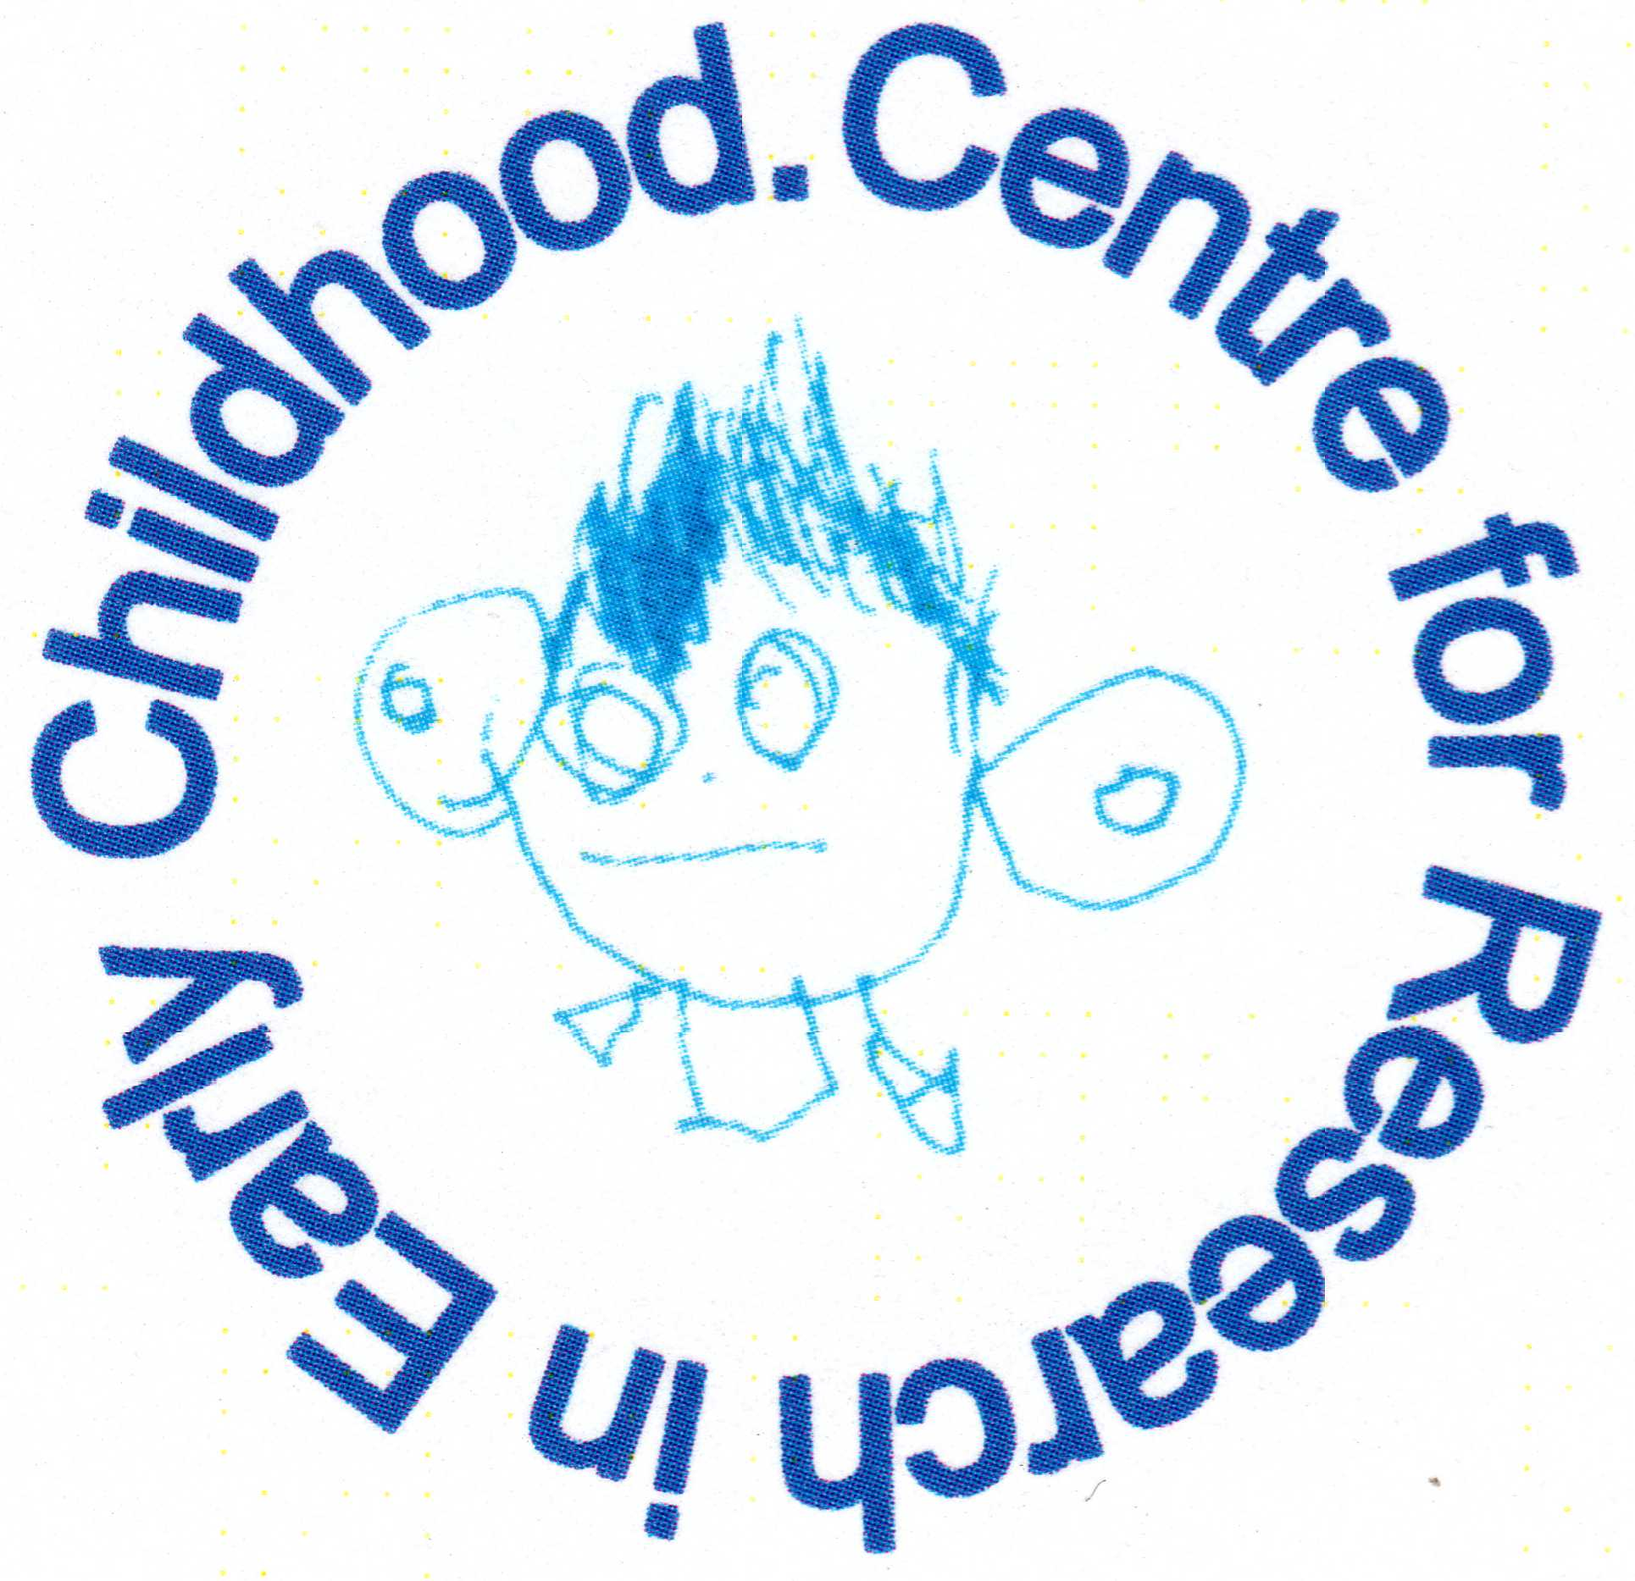
Herlington Community Centre
Orton Malborne
Peterborough
PE2 5PW

Telephone: 01733 390115
Charity No: 1036950
barb.herlingtonpreschool@gmail.com

Valuing diversity and promoting inclusion and equality

Policy statement

We are committed to ensuring that our service is fully inclusive in meeting the needs of all children.

We recognise that children and their families come from a wide range of backgrounds with individual needs, beliefs and values. They may grow up in family structures that include one or two parents of the same or different sex. Children may have close links or live with extended families of grandparents, aunts, uncles and cousins; while other children may be more removed from close kin, or may live with other relatives or foster carers. Some children come from families who experience social exclusion, severe hardship; discrimination and prejudice because of their ethnicity, disability and/or ability, the languages they speak, their religious or personal beliefs, their sexual orientation and marital status. Some individuals face discrimination linked to their gender and some women are discriminated against because of their pregnancy and maternity status. We understand that all these factors can affect the well-being of children within these families and may adversely impact on children’s learning, attainment and life outcomes.

We are committed to anti-discriminatory practice to promote equality of opportunity and valuing diversity for all children and families using our setting. We aim to:
- promote equality and value diversity within our service and foster good relations with the local community;
- actively include all families and value the positive contribution they make to our service;
- promote a positive non-stereotyping environment that promotes dignity, respect and understanding of difference in all forms;
- provide a secure and accessible environment in which every child feels safe and equally included;
- improve our knowledge and understanding of issues relating to anti-discriminatory practice,
- challenge and eliminate discriminatory actions on the basis of a protected characteristic as defined by the Equality Act (2010) namely:
  - age;
  - gender;
  - gender reassignment;
  - marital status;
  - pregnancy and maternity;
  - race;
  - disability;
  - sexual orientation; and
  - religion or belief.
- where possible, take positive action to benefit groups or individuals with protected characteristics who are disadvantaged, have a disproportional representation within the service or need different things from the service.

Procedures

Admissions
Our setting is open and accessible to all members of the community.
- We base our Admissions Policy on a fair system.
- We do not discriminate against a child or their family in our service provision, including preventing their entry to our setting based on a protected characteristic as defined by the Equality Act (2010).
- We advertise our service widely.
- We provide information in clear, concise language, whether in spoken or written form and provide information in other languages (where ever possible).
- We reflect the diversity of our community and wider society in [our/my] publicity and promotional materials.
- We provide information on our offer of provision for children with special educational needs and disabilities.
- We ensure that all parents are made aware of our Valuing Diversity and Promoting Inclusion and Equality Policy.
- We make reasonable adjustments to ensure that disabled children can participate successfully in the services and in the curriculum offered by the setting.
- We ensure, wherever possible, that we have a balanced intake of boys and girls in the setting.
- We take action against any discriminatory, prejudice, harassing or victimising behaviour by our staff, volunteers or parents whether by:
- direct discrimination – someone is treated less favourably because of a protected characteristic e.g., preventing families of a specific ethnic group from using the service;
- indirect discrimination – someone is affected unfavourably by a general policy e.g.; children must only speak English in the setting;
- discrimination arising from a disability – someone is treated less favourably because of something connected with their disability e.g., a child with a visual impairment is excluded from an activity;
- association – discriminating against someone who is associated with a person with a protected characteristic e.g., behaving unfavourably to someone who is married to a person from a different cultural background; or
- perception – discrimination on the basis that it is thought someone has a protected characteristic e.g., making assumptions about someone's sexual orientation.
- We will not tolerate behaviour from an adult who demonstrates dislike or prejudice towards individuals who are perceived to be from another country (xenophobia).
- Displaying of openly discriminatory xenophobic and possibly offensive or threatening materials, name calling, or threatening behaviour are unacceptable on, or around, our premises and will be dealt with immediately and discreetly by asking the adult to stop using the unacceptable behaviour and inviting them to read and to act in accordance with the relevant policy statement and procedure. Failure to comply may lead to the adult being excluded from the premises.

Employment
- We advertise posts and all applicants are judged against explicit and fair criteria.
- Applicants are welcome from all backgrounds and posts are open to all.
- We may use the exemption clauses in relevant legislation to enable the service to best meet the needs of the community.

The applicant who best meets the criteria is offered the post, subject to references and suitability checks. This ensures fairness in the selection process.

All our job descriptions include a commitment to promoting equality, and recognising and respecting diversity as part of their specifications.

We monitor our application process to ensure that it is fair and accessible.

Training
- We seek out training opportunities for our staff and volunteers to enable them to develop anti-discriminatory and inclusive practices.
- We ensure that our staff are confident and fully trained in administering relevant medicines and performing invasive care procedures on children when these are required.
- We review our practices to ensure that we are fully implementing our policy for Valuing Diversity and Promoting Equality.

Curriculum
The curriculum offered in our setting encourages children to develop positive attitudes about themselves as well as about people who are different from themselves. It encourages development of confidence and self-esteem, empathy, critical thinking and reflection.
We ensure that our practice is fully inclusive by:
- creating an environment of mutual respect and tolerance;
- modelling desirable behaviour to children and helping children to understand that discriminatory behaviour and remarks are hurtful and unacceptable;
- positively reflecting the widest possible range of communities within resources;
- avoiding use of stereotypes or derogatory images within our books or any other visual materials;
- celebrating locally observed festivals and holy days;
- ensuring that children learning English as an additional language have full access to the curriculum and are supported in their learning;
- ensuring that disabled children with and without special educational needs are fully supported;
- ensuring that children speaking languages other than English are supported in the maintenance and development of their home languages

We will ensure that Our environment is as accessible as possible for all visitors and service users. We do this by:
- undertaking an access audit to establish if the setting is accessible to all disabled children and adults. If access to the setting is found to treat disabled children or adults less favourably, then we make reasonable adjustments to accommodate the needs of disabled children and adults.
- fully differentiating the environment, resources and curriculum to accommodate a wide range of learning, physical and sensory needs.
Valuing diversity in families
- We welcome the diversity of family lifestyles and work with all families.
- We encourage children to contribute stories of their everyday life to the setting.
- We encourage mothers, fathers and other carers to take part in the life of the setting and to contribute fully.
- For families who speak languages in addition to English, we will develop means to encourage their full inclusion.
- We offer a flexible payment system for families experiencing financial difficulties and offer information regarding sources of financial support.
- We take positive action to encourage disadvantaged and under-represented groups to use the setting.

Food
- We work in partnership with parents to ensure that dietary requirements of children that arise from their medical, religious or cultural needs are met where ever possible.
- We help children to learn about a range of food, and of cultural approaches to mealtimes and eating, and to respect the differences among them.

Meetings
- Meetings are arranged to ensure that all families who wish to may be involved in the running of the setting.
- We positively encourage fathers to be involved in the setting, especially those fathers who do not live with the child.
- Information about meetings is communicated in a variety of ways - written, verbal and where resources allow in translation – to ensure that all mothers and fathers have information about, and access to, the meetings.

Monitoring and reviewing
- So that our policies and procedures remain effective, we monitor and review them annually to ensure our strategies meet our overall aims to promote equality, inclusion and to value diversity.
- We provide a complaints procedure and a complaints summary record for parents to see.

Public Sector Equality Duty
- We have regard to the Duty to eliminate discrimination, promote equality of opportunity, foster good relations between people who share a protected characteristic and those who do not.

Legal framework
The Equality Act (2010)
Children Act (1989) & (2004)
Children and Families Act (2014)
Special Educational Needs and Disabilities Code of Practice (2014)

This policy was adopted by | Herlington Preschool

Further information

- Guide to the Equality Act and Good Practice (Pre-school Learning Alliance 2015)
- SEND Code of Practice 2014 for the Early Years (Pre-school Learning Alliance 2014)
- Where’s Dad? (Pre-school Learning Alliance 2009)

