Herlington Pre-school
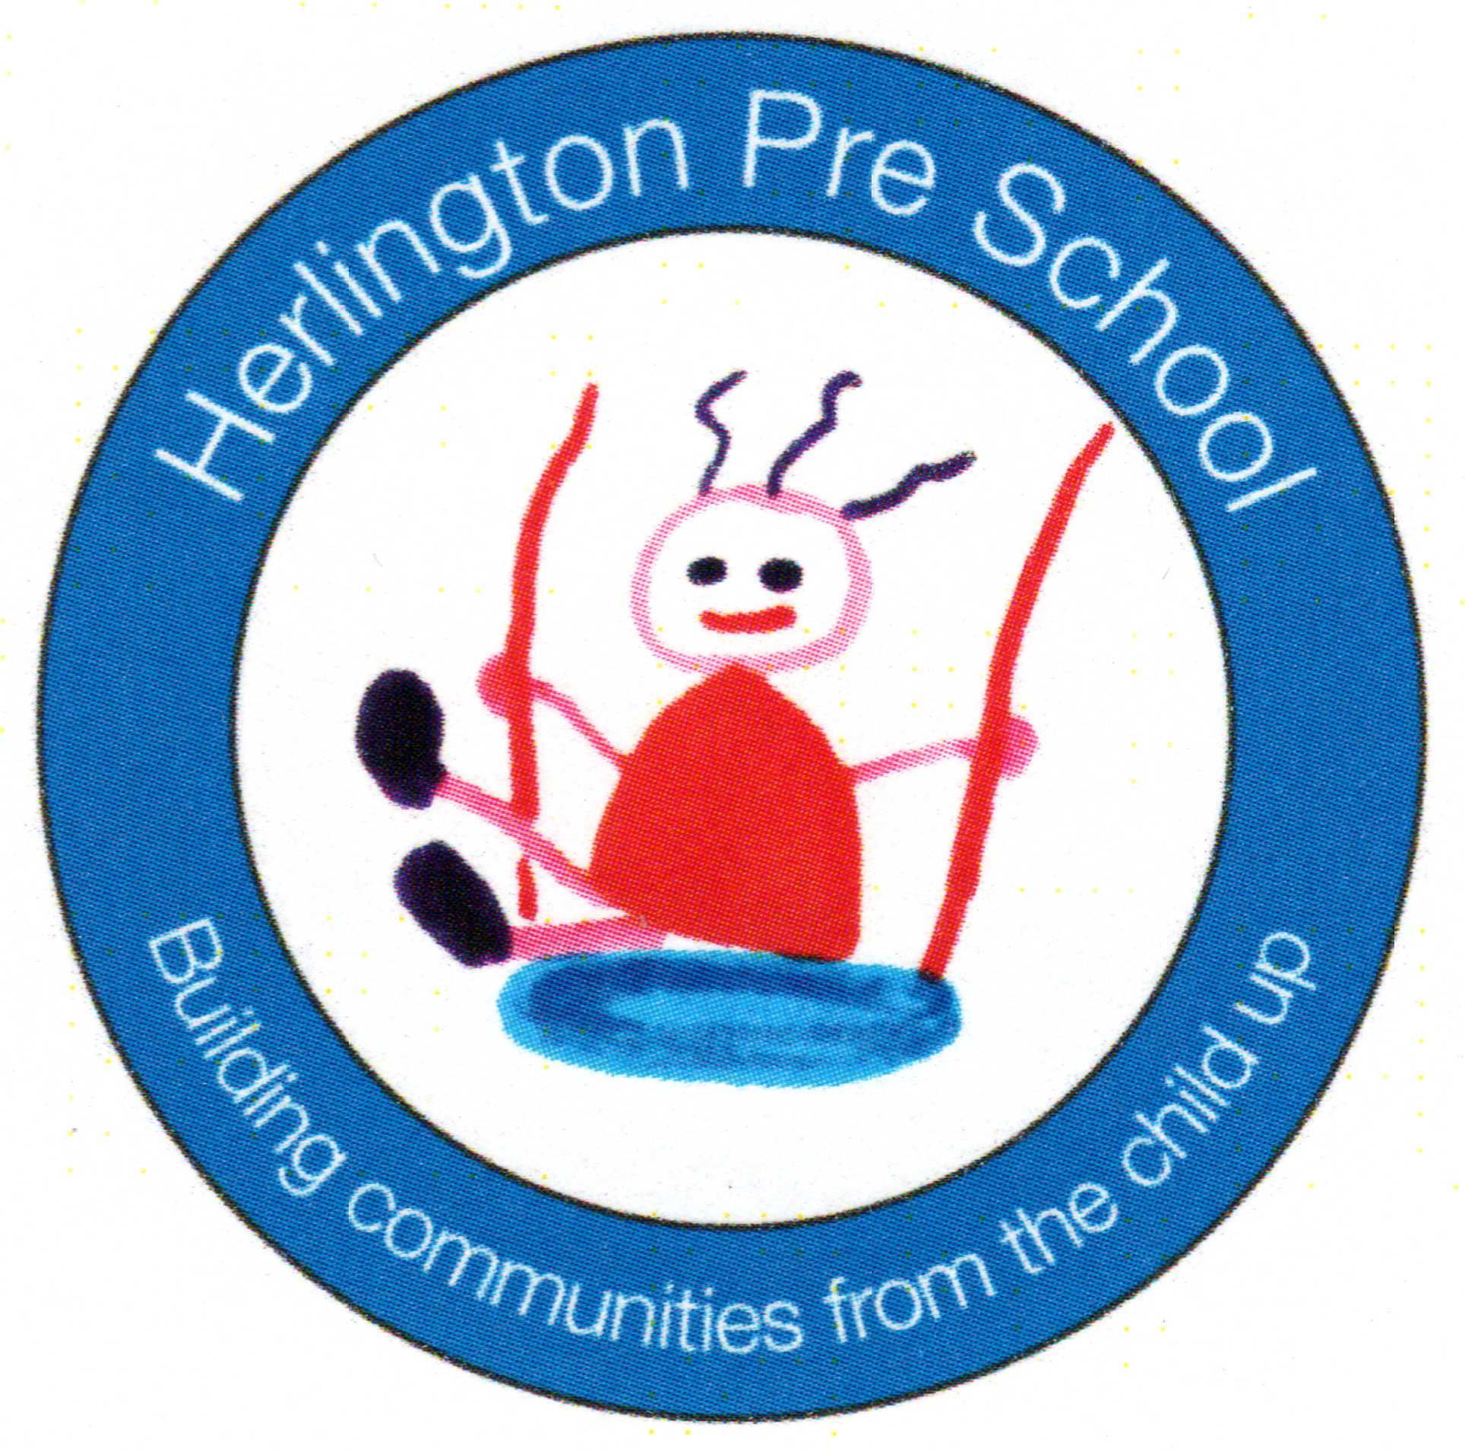
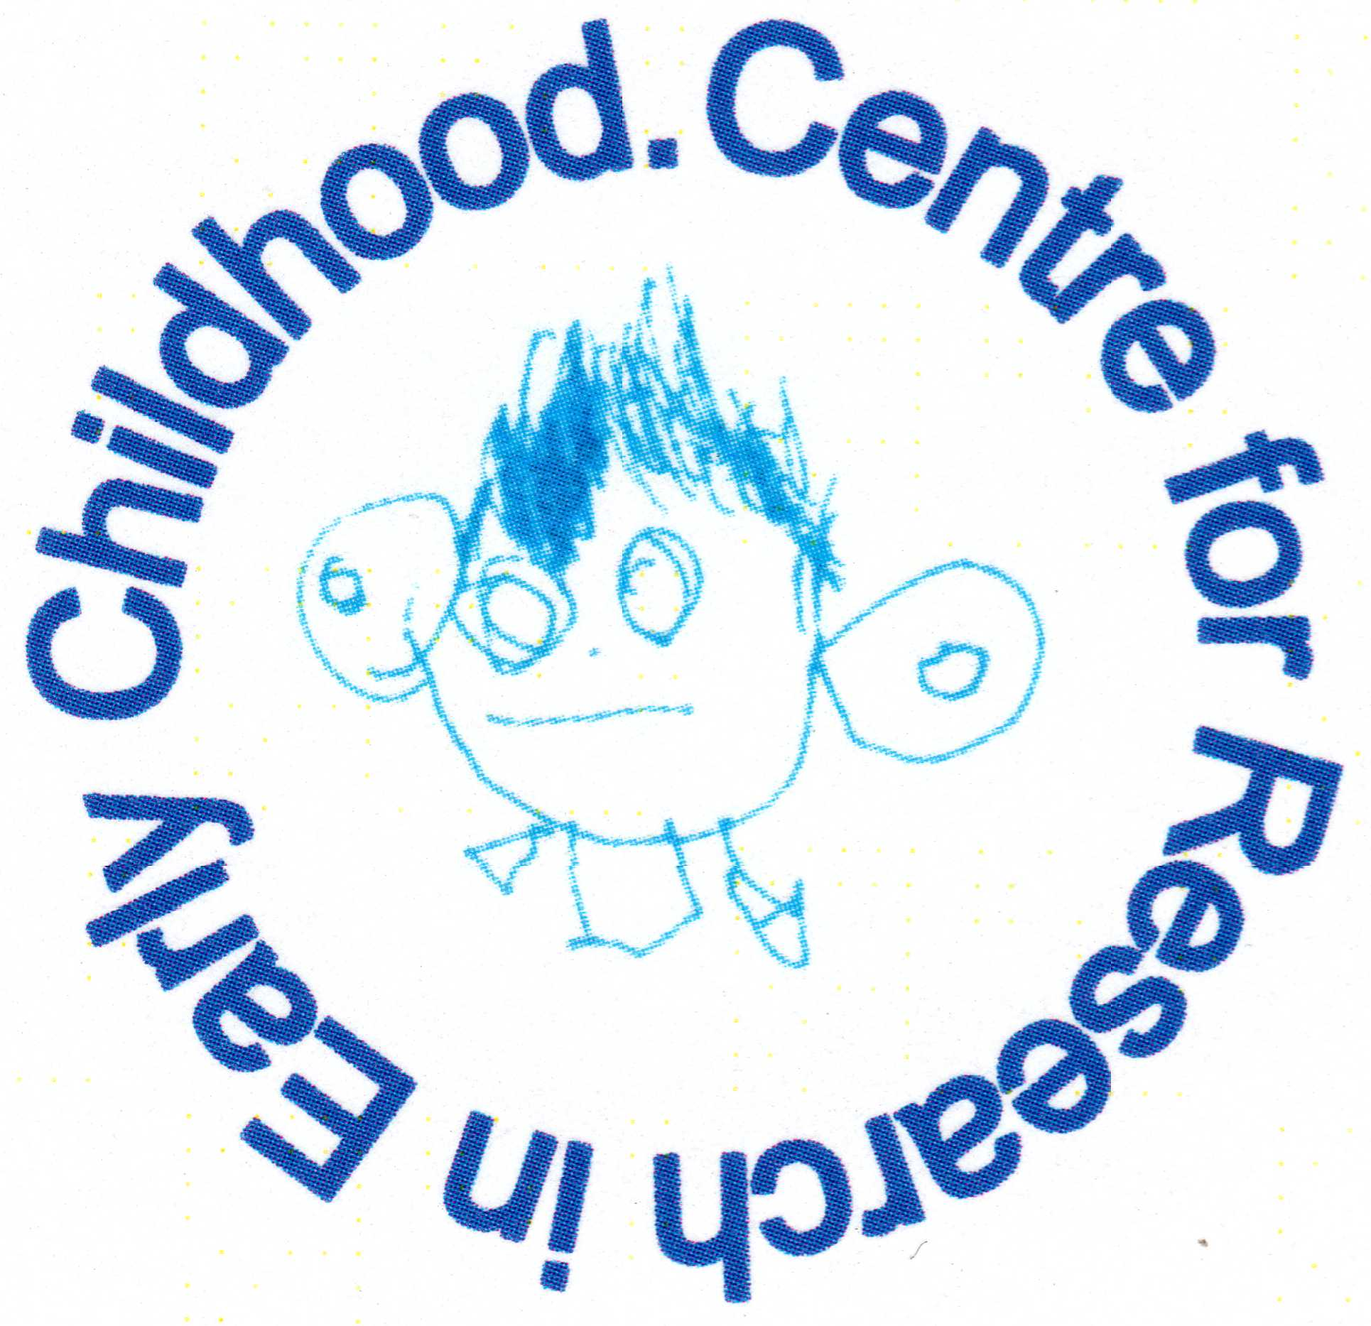
Herlington Community Centre
Orton Malborne
Peterborough
PE2 5PW

Telephone: 01733 390115
Charity No: 1036950
barb.herlingtonpreschool@gmail.com

Emotional Health & Well-being Policy
Well-being
Well-being is a particular state or feeling that can be recognized by satisfaction, enjoyment & pleasure. The person is relaxed and expresses inner rest, feels the energy flow and radiates vitality, is open to the surroundings, accessible and flexible.
Professor Ferre Laevers
Why is well-being important?
Well-being relates to our basic needs as human beings. These are
- Physical needs (need to eat, drink, move & sleep)
- The need for affection, warmth & tenderness (being hugged, receiving & giving love & emotional warmth)
- The need for safety, clarity & continuity (knowing the rules, being able to predict what comes next, counting on others)
- The need for recognition & affirmation (feeling accepted & appreciated by others, being part of a group & having a sense of belonging)
- The need to feel capable (feeling that you are good at something, to experience success)
Intellectual development and social & emotional development are strongly influenced by a child’s experiences during their pre-school years.
Emotional well-being includes being happy and confident and not anxious or depressed. Social well-being allows children to make good relationships.
As part of our ongoing observation, assessment & planning cycle your child’s key person will be monitoring their well-being & involvement and planning activities to support the children in this area. This will be shared with you as part of our parent consultation process. We record children's well-being & involvement as part of our focus observations. These are collated in the child's on-line learning journal. You can view this at any time and add to it if you wish.
Early years practitioners should identify factors that may pose a risk to a child’s social & emotional well-being as part of the on-going assessment of their development. This could include
- A child being withdrawn
- A child being unresponsive
- Children showing signs of a behavioural problem
- Delayed speech or poor communication & language skills
Practitioners understand children’s emotional health needs and have the time & skills to develop nurturing relationships.
Benefits to children & families
- Children who are more engaged with learning
- Parents who are more engaged with the nursery and more in tune with their child’s learning & development
- High morale within the setting
- Good relationships developed between staff, parents & children.
- The good emotional health of the children

This policy was adopted by | Herlington Preschool

