Welcome to Herlington Pre-school

This booklet has been designed to give you all of the relevant information you will need whilst your child/children are attending Herlington Pre-school. We want children to feel safe, stimulated and happy in the Pre-school and to feel secure and comfortable with practitioners. We also want parents to have confidence in both their children’s well-being and their role as active partners with the Pre-school. We aim to make the Pre-school a welcome place where children settle quickly and easily because consideration has been given to their individual needs and circumstances of themselves and their families.

The Pre-school Manager is Barbara Howlett
The Deputy manager is Claire Pacey
They can be contacted by telephone on 01733 390115
or by email barb.herlingtonpreschool@gmail.com

Should you have any queries or concerns please do not hesitate to contact the setting or call in

Our pre-school meets at the following times:

Session Times Cost

Morning Session

Monday 09.00am – 11.30am £8.00 per session
Tuesday 09.00am – 11.30am “ “
Wednesday 09.00am – 11.30am “ “
Thursday 09.00am – 11.30am “ “
Friday 09.00am – 11.30am “ “

Afternoon Sessions

Monday 12.30pm – 3.00pm £8.00 per session
Tuesday 12.30pm – 3.00pm “ “
Wednesday 12.30pm – 3.00pm “ “
Thursday 12.30pm – 3.00pm “ “
Friday 12.30pm – 3.00pm “ “

Breakfast Club 07.45am – 09.00am £5.00 per day

Early drop off 08.30am – 9.00am £3.00 per day

Lunch Club 11.30am – 12.30pm £3.50 per day plus a packed lunch

Pick up (Hampton Only) £5.00 per day (covers breakfast)

Our pre-school operates Government Funded places for 2, 3 and 4 year olds. We will inform you when your child is eligible to receive these places.
Fees are payable at the beginning of each week and must be paid even if the child/children are absent for short periods of time.

If your child will be absent over a long period of time you need to see the Manager to keep your child’s place.

Fees will still be charged at the sessions booked.

You must pay fees owed, if you have difficulties with payments please let us know and we will do our best to help you.

If your child is collected late from the session without prior notice, then extra fees will be charged at £3:00 for every 5 minutes late.

PROCEDURES FOR ILLNESS/ACCIDENTS
If your child/children are ill and unable to attend Pre-school please notify the setting by telephone.
If your child/children has been suffering from Sickness and/or Diarrhoea they need to stay at home for 48 hours after their last bout. This will help to prevent any germs from spreading throughout the setting.
For any other illness (i.e. chickenpox) please contact Barbara or Karen who will advise you of the timescale for when your child/children can return to the setting.
Please note that fees are still applicable during illness except in exceptional circumstances and this will be discussed with you by Barbara or Karen.

Should your child/children be taken ill whilst at school you or the nominated contact person will be contacted and asked to fetch the poorly child/children.

Should your child/children have an accident whilst in the setting the following procedure will take place.
In the case of a minor accident all of the details will be entered into the accident book which you will be asked to sign at the end of the day. Your child/children’s Key Person will be on hand to explain what happened.
If an ambulance needs to be called your child will be taken immediately to hospital and you will be contacted.

Please note that medication may be administered by our managers. A full explanation of the Sickness/Accident procedures can be found in the Policies and Procedures Booklet.

School Bag
It is recommended that your child/children bring a named school bag on a daily basis in which should be the following items:-
Change of clothes (named if possible please)
Nappies if needed
Baby Wipes
Hat
Sun Cream
Tapestry Learning Journal
Each child at Herlington Pre-school will have a Learning Journal on Tapestry
and their own art folder.
These will be readily available for you to see and comment on.
You will also receive an end of year report for your child/children
Events
During the school year Pre-school hold a variety of events. You will be notified of these in the regular newsletters and handouts. Notices will also be placed on the notice boards
Examples of such events are Red Nose Day, Children in Need, Celebrations and Festivals, Treasure Hunts etc.
There will be specific Topics and Themes throughout the year – details of which will be in newsletters and on notice boards.

Holiday Club
Holiday Clubs run every half term, during the Easter Break and 5/6 weeks of the Summer Holidays. PLEASE NOTE that there is NO holiday club during the Christmas Break.
Holiday Club times are 07:45 – 3.00pm
The cost is £20.00 per day and £18.00 per day for siblings

Management Committee

Herlington Pre-school has an active Committee consisting of staff and parents/carers. The members organise fund raising events and also help with the many activities held within the Preschool.
New members are always welcome!! It is an excellent way of meeting other parents and for making new friends!
Notification of all meetings can be found on the Notice Board

Funded Sessions
Government funding is available to all three year olds the term AFTER their 3rd birthday. This will be for 15 hours per week.
We also offer the 30 hours funding for eligible 3 and 4yr olds.
2yr old funding is also available for eligible families.
Managers or Practitioners will explain how to gain the funding.
A form of identity for the child, such as a Birth Certificate or Passport will be needed as proof of birth date. We also require parents National Insurance Numbers and date of birth.

Structure of the Day
Our day will be very flexible and based on children’s interest and learning styles, however there are specific times of the day as follows:-
7.45am – 9.00am Breakfast Club
9.00am Pre-school session begins
9.15am Registration with Key persons
9.30am Free play continuous provision both inside and out
11.15am Group time, ready for lunch time. Children have continuous access to outdoors during this time
11.30am -12.30pm Lunch time (Children have packed lunches)
12.30pm Children arrive for the afternoon session
12.40pm Registration of children with Key persons
12.45pm Free play continuous provision both inside and out
2.15pm Group time and tidy up ready for home time. Children have continuous access to outdoors during this time
3.00pm Home time
It is important that your child is collected on time; there is a fine system in place for late collection of children.
Children’s individual requirements will be met through ongoing observations and the allocation of a Key Person
There will be an area for children to rest if they are tired, to play quietly or to sleep.

Packed Lunch Boxes and Snacks
Snacks are provided during the morning and afternoon sessions at Pre-school. These include fruit, vegetables and biscuits. Water is also available throughout the session, with milk and juice offered at regular intervals
We ask all parents to provide a healthy lunchbox, and ask that you do not fill it with sweets, fizzy or sugary drinks as these will be returned to you at the end of the day. You do not need to provide drinks at lunchtime as Pre-school will provide water, milk or weak juice.
The attached “Top Tips” will give you some information on Healthy Choices for parents/carers to follow to provide the most nutritious lunch box for your child.

Top Tips for packed lunches

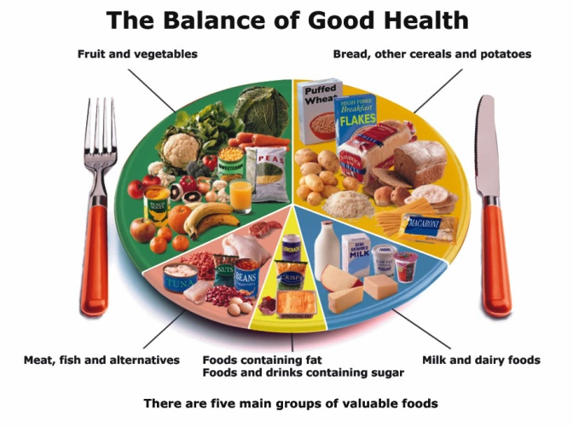

A healthy packed lunch is a balanced lunch. Foods are separated in different groups as above. Try to include something from each to give variety and provide a balance.
Always include carbohydrate food such as bread, other cereals and potatoes. If making sandwiches, vary the bread such as white, multigrain, pitta pockets, tortilla wraps and fruit bread.
You can use leftover items from the previous meal. Why not make a pasta salad with tuna, peppers, tomatoes and onions.
Remember to include some protein foods such as meat, fish and cheese. These are important for growth. Sandwich filling ideas: - Cheese, chutney and grated carrot - Cheese and celery or apple – Tuna and sweetcorn – Peanut butter and cucumber – Egg, tomato and cress – Cooked and chilled Quorn chunks with mayonnaise and sweetcorn.
Aim to include 2 portions of fruit or vegetables in your packed lunch. What is a portion? A portion is approximately the amount of fruit you can hold in your hand such as 1 apple, 7 strawberries, and handful of carrot sticks and a small carton of fruit juice.
Fresh, frozen, dried, tinned or juice (only once per day) all count!
It is best to include a dairy product, as these are a good source of calcium and children need at least 3 per day. These include yogurt or yogurt drink, chunk of cheese, carton of milk and milkshake.
Snack ideas: Cooked mini sausages, breadsticks and dips, hard boiled eggs, party eggs, malt loaf, fruit, carrot cake and cherry tomatoes.
Water and milk are best for teeth. Avoid “juice drinks” which have added sugar. Sugar free squash is better for teeth than sugary drinks.
A packed lunch needs to be kept cool until it is eaten. This will help keep it fresh and ensures food safety. Keep food in your lunch box until the last minute. Use icepacks in lunch boxes to keep food chilled.

