Herlington Pre-school
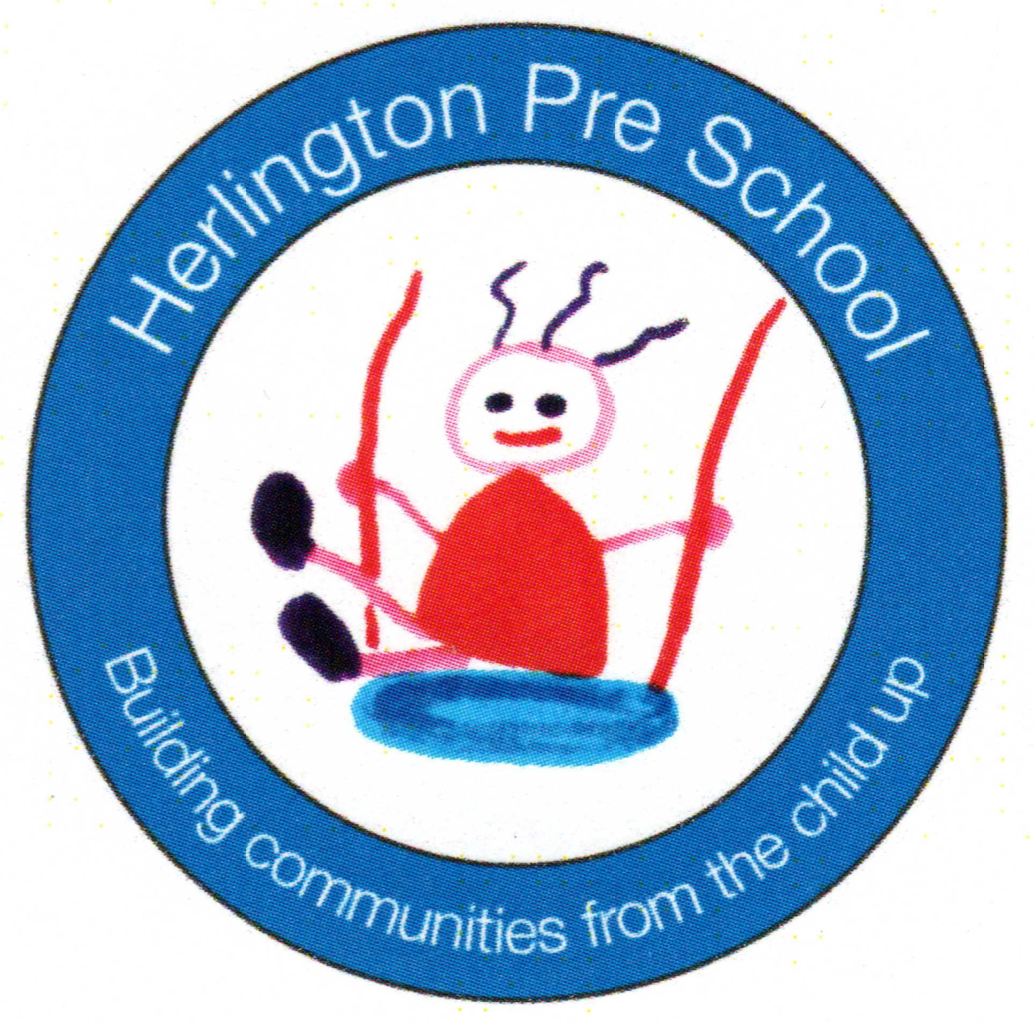
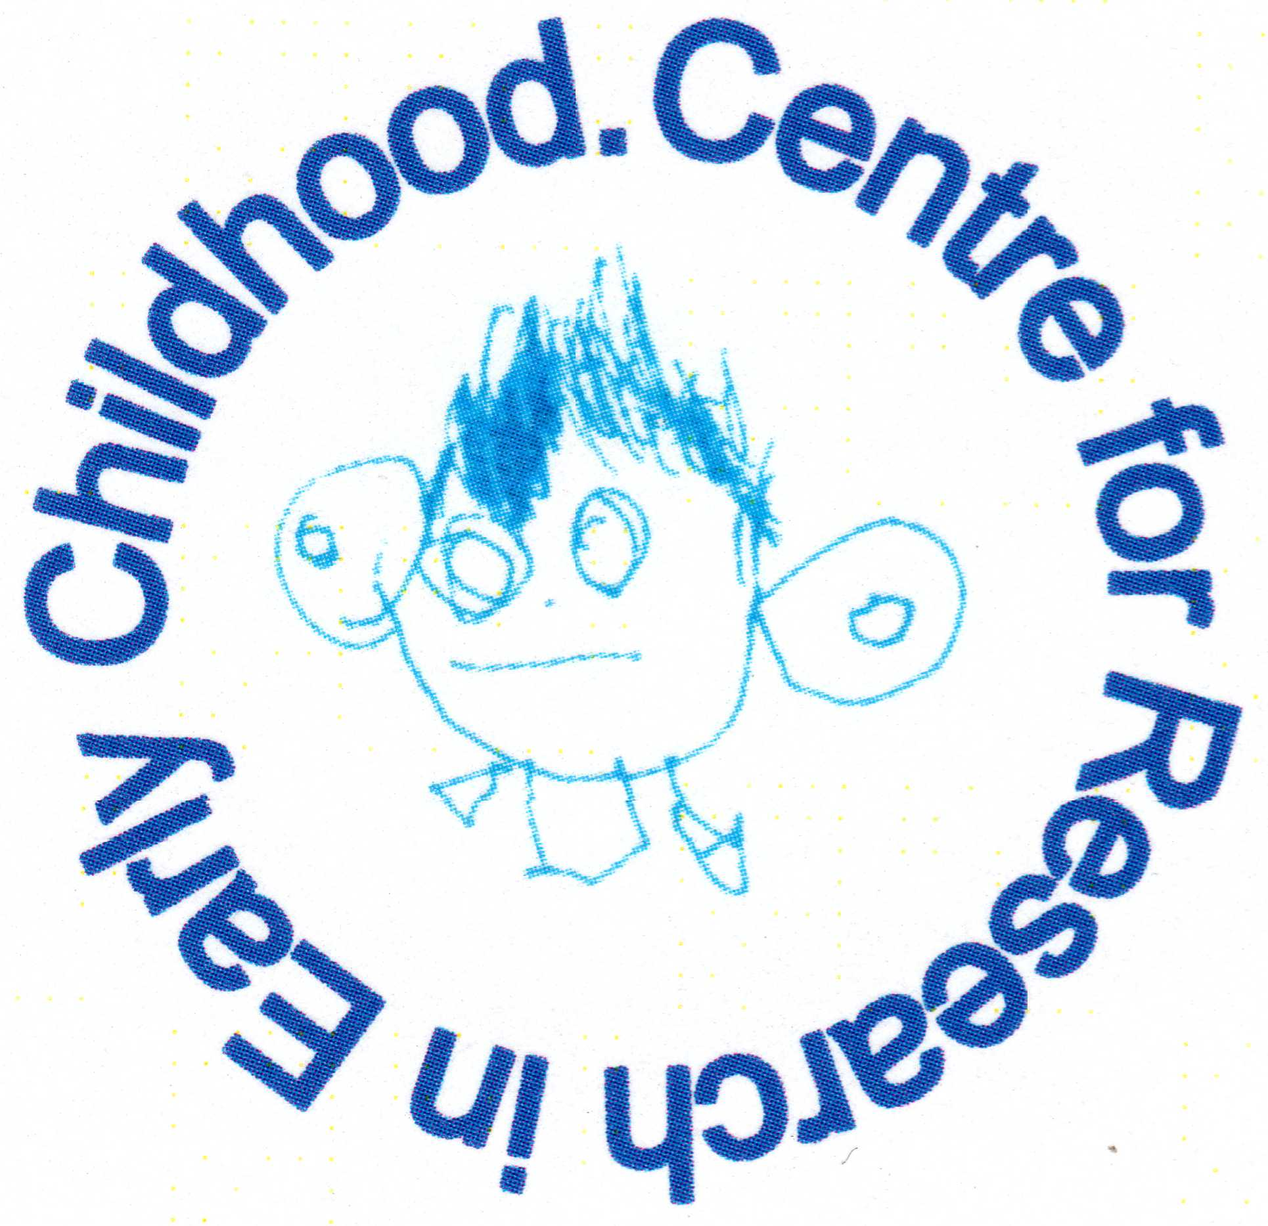
Herlington Community Centre
Orton Malborne
Peterborough
PE2 5PW

Telephone: 01733 390115
Charity No: 1036950
Ofsted number 256771
barb.herlingtonpreschool@gmail.com

Introduction
START is an easy guide to help your child to be ready for school, ready to learn and ready to succeed. By helping your child to be prepared for school, it will build their confidence so that they start school confident, curious and ready to learn. Using positive encouragement can enable your child to feel good about themselves.
Make sure you apply for your child’s school place in good time, the closing date is 15 January each year.

S - shoes, socks and put on clothes
- Allow extra time in the mornings or when going out
- Think about clothes and shoes that will be easier to get on and off
and that are also appropriate for the weather.
- Make sure clothes and shoes have name labels
- Practise making sure clothes and shoes are the right way round
- Practise buttons and zips
- Let your child practise putting on their school uniform
- Give positive praise for trying

T - talking, sharing and following instructions
- Switch off technology for a while
- Talk to your child about what they can see/hear/ smell/feel/taste
- Take your child to meet other children
- Sing songs, read stories or share a book and talk about the pictures daily
- In the evening, talk to your child about their day
- Praise your child for following clear instructions
- Borrow books from your library - It’s free

A - asking for help
- Encourage your child to have a go at things and to ask for help when they need it
- Model how to ask for help using a full sentence: ‘Please can you help me?’
- Let your child ask for things in shops, and be involved in choosing and paying when they’re old enough
- Talk about who to ask and find out who they have good relationships with - such as teachers, other children and nursery staff
- Visit your library to choose a book with your child

R - ready to try different foods and use different tools
- Find fun activities to get the hands and fingers moving e.g. playdough and Lego®
- Sing and play finger-rhymes e.g. Tommy Thumb
- Use pencils, crayons and paintbrushes to practise drawing and painting
- Buy and explore new foods together and praise your child for trying new things
- Show your child how to hold and use a knife, fork, spoon and scissors
- Eat family meals together

T - toilet on their own
- Talk to your child about using the toilet and washing their hands
- Remind your child to wash their hands after the toilet and before eating
- Make sure your child wears clothes they can take down themselves
- Give positive praise for trying to do this independently
- Ask for support from your health visiting team (aged 0-5 years) or school nurse (school age child)
- Tell your child it’s okay to ask to use the toilet at school

